RESOLUTION NO.__________

RE: CERTIFICATE OF APPROPRIATENESS UNDER THE
PROVISIONS OF THE ACT OF THE PENNSYLVANIA
LEGISLATURE 1961, JUNE 13, P.L. 282 (53
SECTION 8004) AND BETHLEHEM ORDINANCE NO.
3952 AS AMENDED.

WHEREAS, it is proposed to install a sign at 821 E. Fourth Street.

NOW, THEREFORE, BE IT RESOLVED by the Council of the City of Bethlehem that a Certificate of Appropriateness is hereby granted for the work.

Sponsored by: (s)

(s)

ADOPTED BY COUNCIL THIS DAY OF

(s)
President of Council

ATTEST:

(s)
City Clerk

HISTORIC CONSERVATION COMMISSION

CASE # 582– It is proposed to install a sign at 821 E. Fourth Street
OWNER/APPLICANT: DG Commons, LLC/ Michelle Thorpe

The Commission upon motion by Ms. Starbuck seconded by Mr. Evans adopted the proposal that City Council issue a Certificate of Appropriateness for the proposed work described herein:
- The proposal to install a sign at 821 E. Fourth Street was presented by Michelle Thorpe.
- A new sign reading “Above & Beyond Care Learning Center” with blue, pink & yellow lettering with logo above will be installed on the front display window.
- The size of the sign will be approximately 42” x 20” instead of the proposed 50” x 33¼”. The size will be adjusted so that there is approximately 10-11” of glass on either side of graphic.
- The business hours will be installed on the door in white or off-white lettering with 2” of glass on either side of the text. The sign will be approximately centered on the door.
- The proposed motion was unanimously approved.

CU: cu
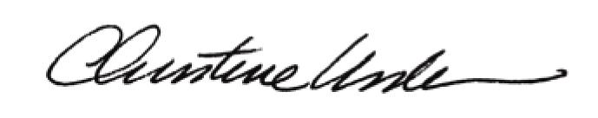

By:

Date of Meeting: March 21, 2016 Title: Historic Officer

